# Visual Sitemap

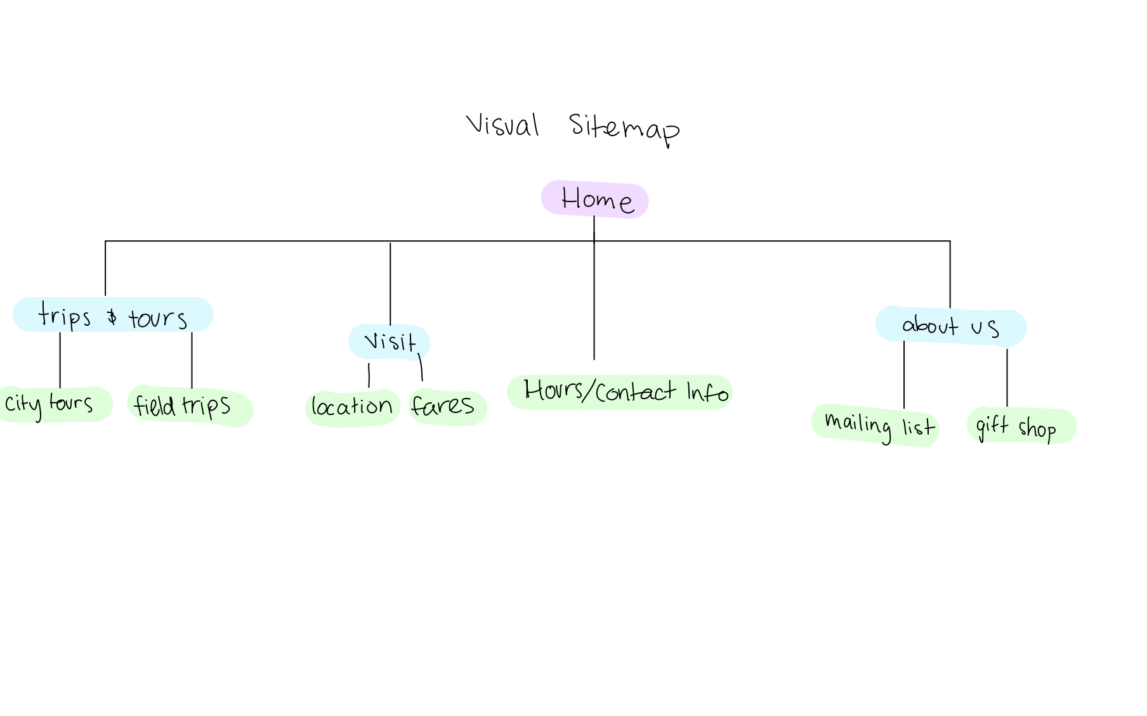

# Information Architecture

Information architecture is important to consider when designing a website to make sure all the content is organized logically for easy navigation by the users. The information architecture influences navigation by establishing consistent structures for how the information is categorized and labeled. I took this into account when designing my website which is why I have each webpage with the same overall template of the different sections clearly organized on the different colored background blocks. This makes it clear so the users know that they should scroll down to see the other colored blocks because they will know there is more information there. Additionally, my methodology followed grouping the information into the different pages so all the information on a single page is related and is linked to by descriptive names in the navigation bar. Since there are multiple ways to visit the incline whether it is through a tour or just on your own, I used this distinction to separate the information into two categories, the Tours which includes information of both tours that include the Duquesne Incline and Field Trip options, and the visit webpage which is more catered towards individuals or families making their own trip to the Incline, thus including information on the fares and the map with the location of the attraction.

# First-Time vs. Returning Visitors

My website is designed to engage new users and make sure returning visitors have an easy time accessing the information they are looking for. To do this I started off the homepage with the image slideshow to engage new visitors with the beautiful views that the incline offers with the hours of operation right below which is important for new visitors and returning visitors who need to quickly find the hours so they can plan their trip. After that, I had the next two navigation links to the Tours and Visit information which is useful and gives easy access for new visitors to explore the different options while it engages the existing visitors to go directly to the type of visit they are interested in. For this reason I put the About Us at the end of the navigation links because while it is very useful information it is more directed at returning visitors who are interested in the history behind the incline and are interested in joining the mailing list and/or purchasing gift shop products. Thus, since returning visitors have likely already spent time on the website they are more likely to look at all the pages while first-time visitors will likely be looking more for the information directly related to making their trip a reality. Additionally, since a lot of the About Us page is heavy on text, I added the image which also acts as a link to the facebook site to engage the visitor more with the page.

# Design Evolution

The transition from the wireframes to development was done in multiple steps with user input at multiple stages. My initial wireframes had an overall similar layout as my final website with the same colored blocks to organize the code and the JQuery based form validation, Google Maps API, and embedded video. After making the wireframes, I had a couple of my peers look over it and give me feedback on what parts were clear to navigate and which parts could be improved. Some feedback I got which I incorporated into my development was to make the Hours of Operation and Contact Information into a table so the different pieces of information were more clearly represented. Additionally, I took the idea of making a template from the Web Dev Lab 6 and applied it to my website. Based on the wireframes, I knew I wanted a pretty consistent layout throughout the different webpages and the first thing I did was create a template with the different sections represented by the different colors. Then, I added the interactive elements like the image carousel and the embedded map, and finally I added the static text. After completing the first pass at the website, I performed the interviews and collected a lot of very useful feedback which I then worked to incorporate into my final development. The main feedback I got was to change the font to make it more readable which I did and to organize the text on the visit page so it takes up more of the page. I made these changes and added more CSS formatting to the different headings which helped the reliability across the pages.